Short term plan: term 3

Unit: 5 Reading for pleasure |  | Lesson 49
Teacher name: |  | Zhakipova Makpal Abdullaevna
Date: |  | 16.01.2024
Grade: 10 |  | Number present: | absent:
Lesson title | Types of literature. The war of the worlds
Learning objectives | 10.3.4.1 - evaluate and comment on the views of others in a growing variety of talk contexts on a growing range of general and curricular topics;  10.3.2.1 - ask and respond to complex questions to get information about a wide range of general and curricular topics;  10.4.8.1 - use a wide range of familiar and unfamiliar paper and digital reference resources to check meaning and extend understanding;
Lesson objectives | Learners will be able to:  -present vocabulary for types of literature;  - to introduce the topic  - read for specific information
Plan

Stages / Time | Teachers actions | Students actions | Assessment criteria | Resources
Beginning of the lesson  Warming-up  3 min.  Pre-learning  «Brainstorming» method  7 min. | Organization moment :  1.Greeting.  Ask about the weather.  The teacher sets the lesson objectives, letting students know what to anticipate from the lesson.  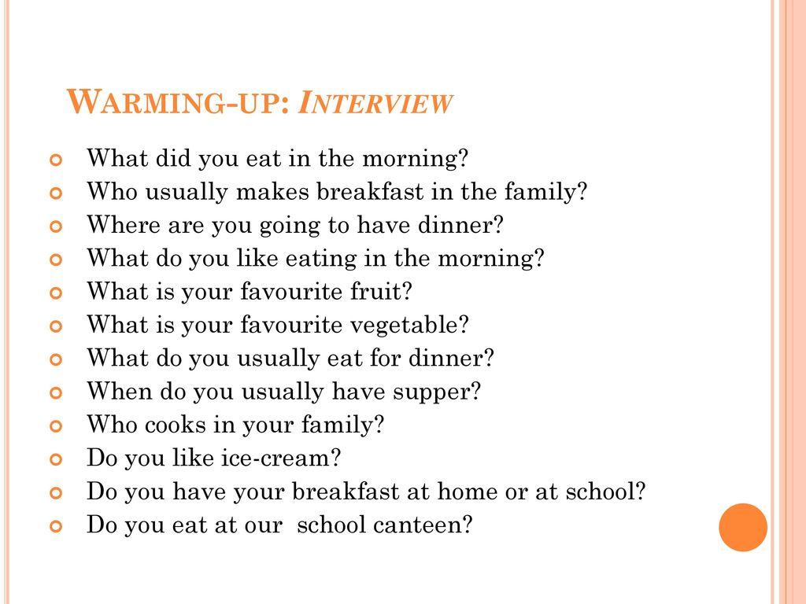  Lead – In  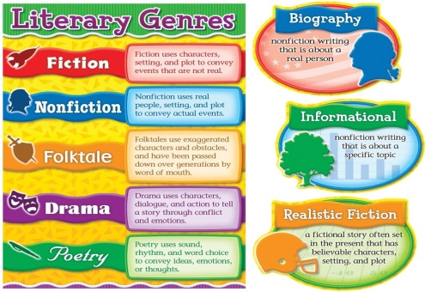 | The aim: To develop pupils speaking skills and create friendly atmosphere  Students of the class are listed.  Students' attention is drawn to the lesson.  Students say different words from the picture  •Learners remember previous lesson vocabulary  •Learners answer the questions | The teacher to assess learners for their ability.  “Good job!  Well done!”  Formative Assessment    Good job!  Descriptor:  - remembers the lesson passed  Point 1  Assessment criteria  make basic statements related to personal information, people and objects | Pictures  worksheet  Picture
Middle of the lesson  Presentation part.  30 min | Ex:1 P:63  • Direct Ss to the pictures. Explain that they show book covers for different types of literature.  Elicit which ones are fiction and which ones are non-fiction from Ss around the class.  Differentiation: «Verbal support» method is used to help Ss use new words in the sentences.  Ex: 2 P: 63  • Read out the adjectives in the list and explain/ elicit their meanings.  Then ask Ss to read the example and elicit similar sentences from Ss around the class about which books they like to read and why.  Ex:3 P64  • Give Ss time to read the text and answer the question. Elicit an answer from the class.  Ex: 4 P: 64  • Have Ss ask and answer questions in pairs about H.G. Wells following the example.  Monitor the activity around the class.  Ex: 5 P: 64  • Explain the task and ask Ss to read the statements and then read the text and mark them according to what they read.  Check Ss' answers.  Conclusion during the lesson some tasks differentiated by outcomes of the students and by their abilities. | • Learners look at the pictures. Answer the question.  ANSWERS  Fiction: A, C, D, H  Non-fiction: B, E, F, G  • Learners use ideas from the list. Answer the question.  ANSWERS  I enjoy science-fiction books as I find them thrilling and imaginative. I don't like travel books. I find them a waste of time  • Pupils read about H.G. Wells. Answer the question  ANSWERS  H.G. Wells wrote science-fiction novels.  • Pupils ask and answer the question as the example.  ANSWERS  B: He worked as a shop assistant, a chemist's assistant, a teaching assistant and a teacher. What did he study at college?  A: He studied biology. Who did he marry?  B: He married Amy Catherine Robbins. What was his first novel?  A: 'The Time Machine'. What other novels did he write?  B: 'The Invisible Man' and 'The War of the Worlds'. When did he die?  A: In 1946  • Pupils read the text and mark the statements  ANSWERS  1T 2 F 3 T 4 DS 5 F | Descriptor:  - look at the pictures.  -answer the question  Total: 2 point  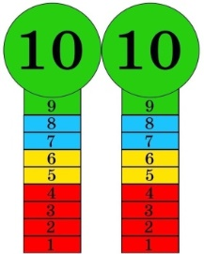  Self assessment  Descriptor:  - use ideas from the  - answer the question  Total: 2 point  Descriptor:  - read about H.G. Wells.  - answer the question  Total: 2 point  Descriptor:  - ask and answer the question  -use the example  Total: 1 point  Descriptor:  - read the text  - mark the statements  Total: 2 point  -Make CCQ questions Yes / No  Total: 1 point |   Card  Worksheet  Students book
End of the lesson  5 min | FEEDBACK  Learners provide feedback on what they have learned at the lesson.  Ex: P:  Home task:  Write the days | 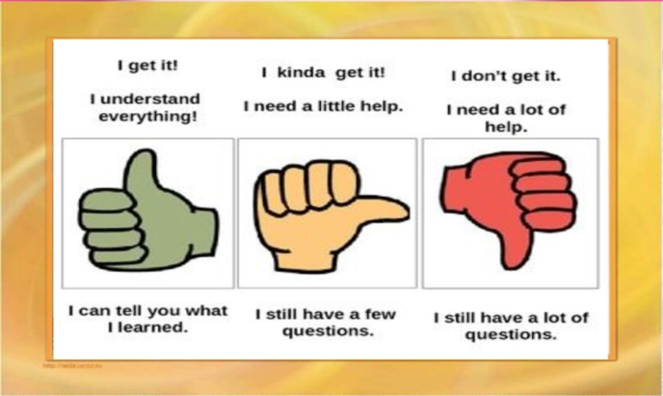 |  | Poster Success  

